Homework – 2
Harshil Panchal, Atharv Wayse, Tanvi Vijay, Prabhu Sana
 | Presidential Election Outcome
Introduction of the new model | Incumbent | Challenger
Yes | -35 | 45
No | -3 | -3
Question 1

- Find the expected payoffs of the two alternatives. Which is better?
Solution:
Since, the probability of winning the election 50% for the parties,
Expected Payoff (Yes – Launch)
E(Yes) = (-35 * 0.5) + (45 * 0.5)
= -17.5 + 22.5
= 5

Expected Payoff (No-Don’t Launch)
E(No) = (-3 * 0.5) + (-3 * 0.5)
= -1.5 + -1.5
= -3

The expected payoff for Launching the new model is 5 million which is greater than expected payoff for not launching the model. Therefore, the better alternative is to launch the new model.

- Compute EVSI and Decision Tree
Solution:
P(Inc) = P(Chal) = 0.5

Estimates:
P (predicted Inc | Inc) = 0.8
P (predicted Chal | Inc) = 0.2
P (predicted Inc | Chal) = 0.3
P (predicted Chal | Chal) = 0.7

Marginal Probabilities,
P (predicted Inc) = 0.8(0.5) + 0.3(0.5) = 0.4 + 0.15 = 0.55
P (predicted Chal) = 1 – 0.55 = 0.45

Using Bayes’ Theorem,
P (Inc | predicted Inc) = (P (predicted Inc | inc) – P (inc)) / P (predicted inc)
= (0.8 * 0.5) / 0.55 = 0.7272
P (Chal | predicted Inc) = 1 – 0.7272 = 0.2727
P (Chal | predicted Chal) = (P (predicted Chal | Chal) – P (Chal)) / P (predicted Chal)
= (0.7 * 0.5) / 0.45 = 0.7777
P (Inc | predicted Chal) = 1 – 0.7777 = 0.2222

Expected Payoffs,
E (Launch | predicted inc) = (0.7272) (-35) + (0.2727) (45) = -13.18
E (don’t | predicted inc) = -3
E (Launch | predicted Chal) = (0.7777) (45) + (0.2222) (-35) = 27.22
E (don’t | predicted Chal) = -3

EVSI = (0.55) * (-3) + (0.45) * (27.22) = 10.6

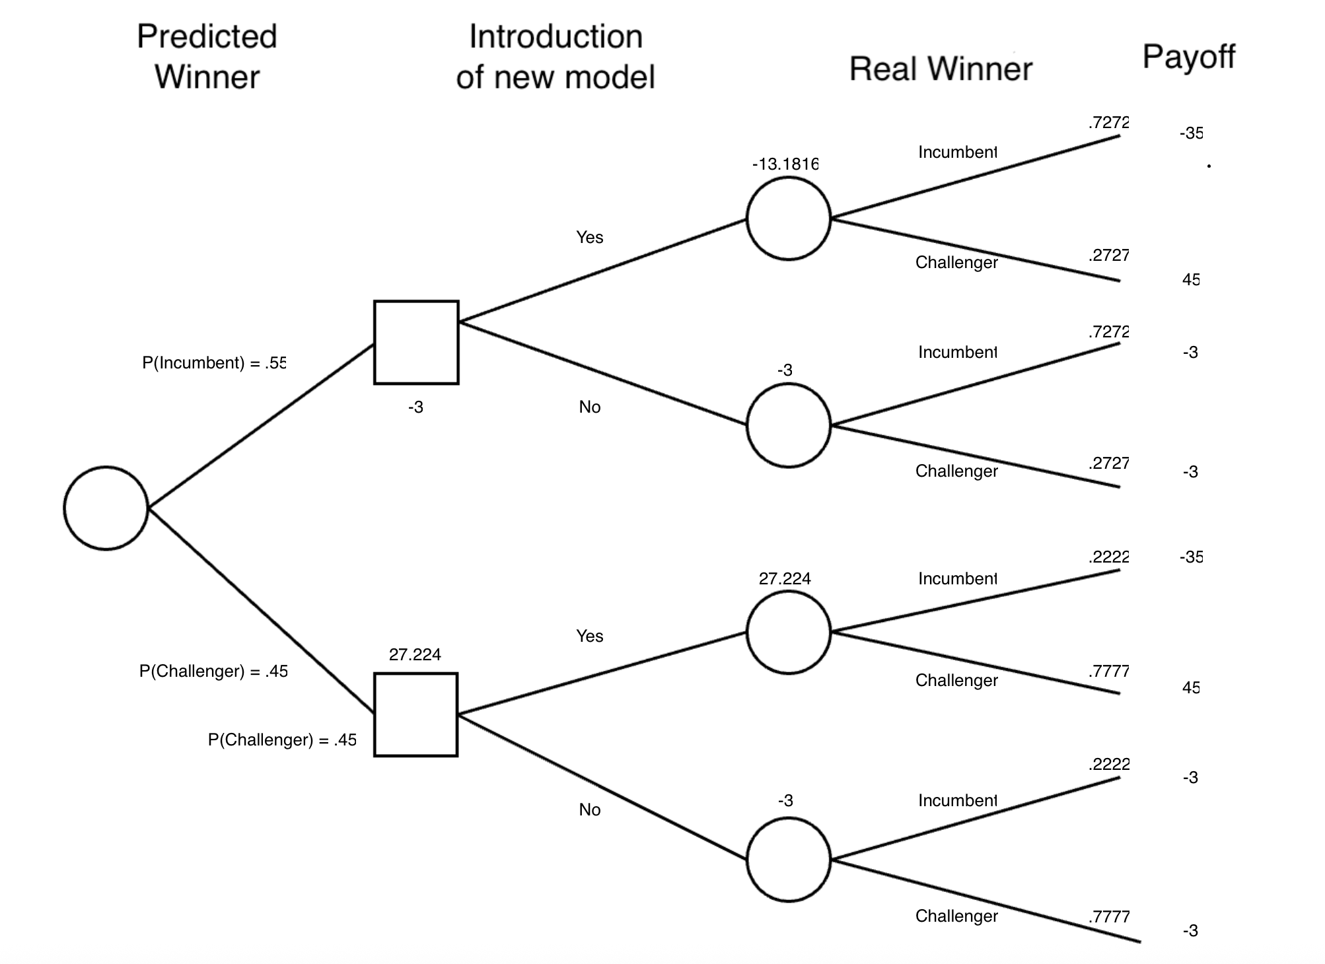
Question 2
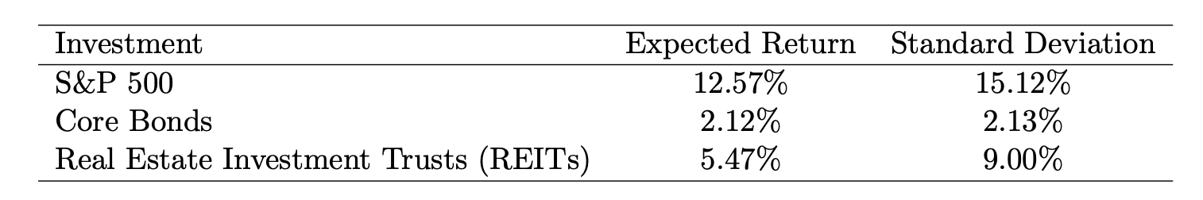
ρS&P, Bonds=−0.32, ρS&P, REITs = 0.74, ρBonds, REITs=−0.04

Answer:
It’s given that: ρS&P, Bonds = −0.32, ρS&P, REITs = 0.74, ρBonds, REITs = −0.04
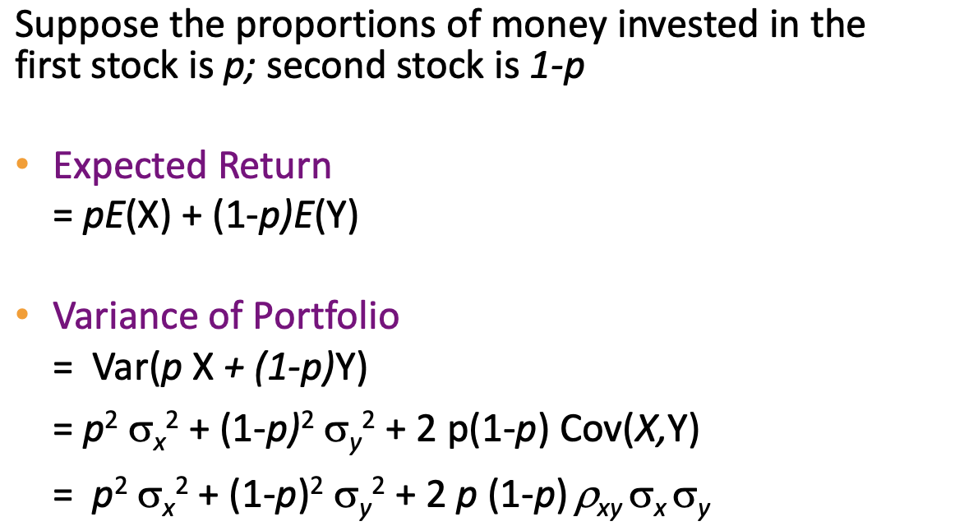
- Construct a portfolio that is 50% in S&P 500 and 50% in REITs. Compute the expected return and standard deviation of this portfolio.
portfolio that is 50% in S&P 500 and 50% in REITs:

Expected return = 50% * E(S&P 500) + (1-50%) * E(REITs) = 50% * 12.57% + 50% * 5.47% = 9.02%
Variance:
(50%)² * σ(S&P 500)² + (1-50%)² * σ(REITs) ² + 2 * 50% * (1-50%) * ρS&P, REITs * σ(S&P 500) * σ(REITs)
= (0.5)² * (15.12/100)² + (1-0.5)² * (9/100) ² + 2 * 0.5 * (1-0.5) * 0.74 * (15.12/100) * (9/100) = 1.28%
Standard Deviation = square root of 1.28% = 11.30%

- Construct a portfolio that is 50% in Core Bonds and 50% in REITs. Compute the expected return and standard deviation of this portfolio.
portfolio that is 50% in Core Bonds and 50% in REITs:
Expected return = 50% * E(Core Bonds) + (1-50%) * E(REITs) = 50% * 2.12% + 50% * 5.47% = 3.80%
Variance:
(50%)² * σ(Bonds)² + (1-50%)² * σ(REITs) ² + 2 * 50% * (1-50%) * ρBonds, REITs * σ(Bonds) * σ(REITs)
= (0.5)² * (2.13/100)² + (1-0.5)² * (9/100) ² + 2 * 0.5 * (1-0.5) * -0.04 * (2.13/100) * (9/100) = 0.21%
Standard Deviation = square root of 0.21% = 4.58%

- Construct a portfolio that is 80% in Core Bonds and 20% in REITs. Compute the expected return and standard deviation of this portfolio.
portfolio that is 80% in Core Bonds and 20% in REITs:
Expected return = 80% * E(Core Bonds) + (1-80%) * E(REITs) = 80% * 2.12% + 20% * 5.47% = 2.79%
Variance:
(50%)² * σ(Bonds)² + (1-50%)² * σ(REITs) ² + 2 * 50% * (1-50%) * ρBonds, REITs * σ(Bonds) * σ(REITs)
= (0.5)² * (2.13/100)² + (1-0.5)² * (9/100) ² + 2 * 0.5 * (1-0.5) * -0.04 * (2.13/100) * (9/100) = 0.06%
Standard Deviation = square root of 0.06% = 2.43%

- Based on your results, which portfolio would you recommend to an aggressive investor? Which would you recommend to a conservative investor? Justify your answer.
Recommendation:
  - For the Aggressive investor, the 50% S&P 500 and 50% REITs portfolio is suitable for higher risk tolerance, as it with the highest expected return (9.02%) with relatively high risk (11.3%)
  - For the Conservative investor, the 80% Core Bonds and 20% REITs portfolio is better suited for risk-averse investors seeking capital preservation, as it is with the lowest risk (2.43%) and modest return (2.79%).

Question 3

Answer:
Based on the given data, it’s a discrete distribution, and it follows a binomial distribution:
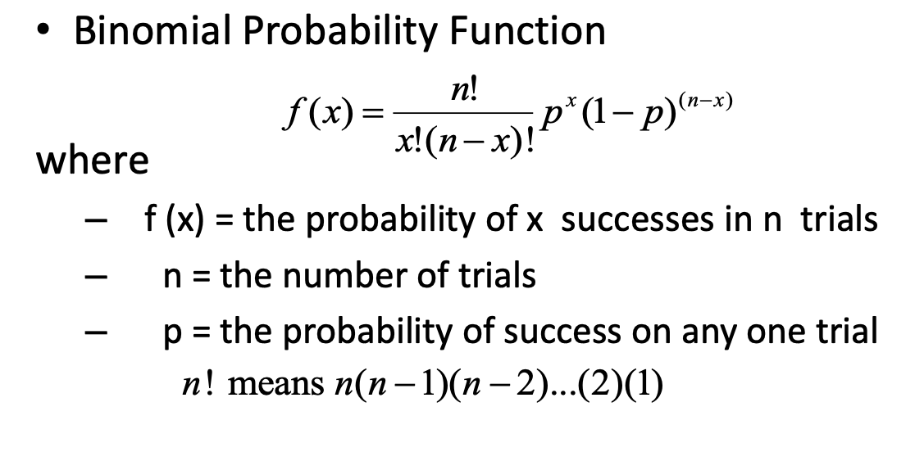
Here, n = 25 retail investors
p = 18% = 0.18 investors hold cryptocurrency in their portfolios
- Compute the probability that exactly 7 investors hold cryptocurrency in their portfolios.
Probability that exactly 7 investors hold cryptocurrency in their portfolios:
f(X = 7) = (25C7) * (0.18)⁷ * (1-0.18)⁽²⁵⁻⁷⁾ = 8.27%

- Compute the probability that at least 10 of the investors hold cryptocurrency in their portfolios.
probability that at least 10 of the investors hold cryptocurrency in their portfolios:
f(X >= 10) = 1 – f(X<= 9)

f(X<= 9) is:
sum of f(X = 0), f(X = 1), f(X = 2), f(X = 3), f(X = 4), f(X = 5), f(X = 6), f(X = 7), f(X = 8), f(X = 9)

f(X = 0) = (25C0) * (0.18)⁰ * (1-0.18)⁽²⁵⁻⁰⁾ = 0.70%
f(X = 1) = (25C1) * (0.18)¹ * (1-0.18)⁽²⁵⁻¹⁾ = 3.84%
f(X = 2) = (25C2) * (0.18)² * (1-0.18)⁽²⁵⁻²⁾ = 10.12%
f(X = 3) = (25C3) * (0.18)³ * (1-0.18)⁽²⁵⁻³⁾ = 17.04%
f(X = 4) = (25C4) * (0.18)⁴ * (1-0.18)⁽²⁵⁻⁴⁾ = 20.57%
f(X = 5) = (25C5) * (0.18)⁵ * (1-0.18)⁽²⁵⁻⁵⁾ = 18.97%
f(X = 6) = (25C6) * (0.18)⁶ * (1-0.18)⁽²⁵⁻⁶⁾ = 13.88%
f(X = 7) = (25C7) * (0.18)⁷ * (1-0.18)⁽²⁵⁻⁷⁾ = 8.27%
f(X = 8) = (25C8) * (0.18)⁸ * (1-0.18)⁽²⁵⁻⁸⁾ = 4.08%
f(X = 9) = (25C9) * (0.18)⁹ * (1-0.18)⁽²⁵⁻⁹⁾ = 1.69%
So, P(X<=9) = 0.70% + 3.84% + 10.12% + 17.04% + 20.57% + 18.97% + 13.88% + 8.27% + 4.08% + 1.69% = 99.16%
P(X >= 10) = 1 – P(X <= 9) = 1 - 99.16% = 0.84%

- Suppose you observed that 12 investors in the group hold cryptocurrency. Would this observation make you question the accuracy of the 18% figure? Explain your reasoning.
For X = 12 retail investors:
P(X = 12) = (25C12) * (0.18)¹² * (1-0.18)⁽²⁵⁻¹²⁾ = 0.05%
As the probability is very less, it seems the 12 investors in the group holding crypto is very unlikely with 18% accuracy. Hence, it raises the question of 18% accuracy.

- If the first 5 investors in the sample are known to all hold cryptocurrency, what is the probability that exactly 7 investors in total hold cryptocurrency in the group of 25?
As it’s mentioned that the first 5 investors in the sample are known to all hold cryptocurrency, we need 2 more investors out of the remaining 25 – 5 = 20 investors.
So, P(X = 2) = (20C2) * (0.18)² * (1-0.18)⁽²⁰⁻²⁾ = 17.30%
So, the probability that exactly 7 investors in total hold cryptocurrency in the group of 25 based on the above condition is 17.30%

Question 4
- The company wants to offer a warranty for the top 90% of its batteries. What is the minimum number of charge cycles a battery must last to qualify for this warranty?
Solution:
Minimum number of charge cycles for a battery to be in top 90%
To find, bottom 10th Percentile ->
μ = 4500, σ = 420, z-score for 10th percentile = -1.285 (from standard normal table)
X = μ + zσ = 4500 + (-1.285) * 420 = 3960.3
Therefore, a battery must last for at least 3961 charge cycles to qualify for this warranty.
- A customer purchases an EV battery and manages to achieve 5200 charge cycles before reaching 80% capacity. What is the probability that a randomly selected battery lasts at least this long?
Solution:
battery achieves 5200 charge cycles. Probability for a battery to last this long is equal to ->
μ = 4500, σ = 420, P(X>=5200) = 1 – P(X<5200)
Z-score = (X – μ)/ σ = (5200-4500) / 420
= 1.66
z-score corresponding to 1.66 = 0.9515
= 1 – 0.9515
= 0.0475
= 4.75%
Therefore, the probability that a randomly selected battery lasts at least this long is 4.75%.

- The company wants to ensure that only 5% of batteries fail before 3500 charge cycles. What should be the minimum lifetime guaranteed to achieve this goal?
Solution:
Minimum life guaranteed to achieve this goal ->
μ = 4500, σ = 420, z-score for 5th percentile = -1.645 (form standard normal table)
X = μ + zσ = 4500 + (-1.645) * 420 = 3809.1
Therefore, the minimum lifetime guaranteed to achieve this goal is 3610 batteries.
- Suppose the batteries are tested in batches of 50 units. Approximately how many batteries in a batch would you expect to fail before 4000 charge cycles?
Solution:
Expected number of batteries to fail in a batch before 4000 charge cycles ->
μ = 4500, σ = 420, P(X<4000)
Z-score = (X – μ)/ σ = (4000-4500) / 420
= -1.19
z-score corresponding to -1.19 = 0.1170
= 11.7%
Expected number of batteries to fail in a batch = 50 * 11.7% = 6 batteries
There can be about 6 batteries in a batch of 50 to fail before 4000 charge cycles.
Contributions
For this homework, Harshil and Atharv worked on Questions 1 and 4, while Tanvi and Prabhu worked on Questions 2 and 3. After completing our parts, each of us double-checked one another’s work to ensure accuracy and consistency. Finally, we merged all of our individual contributions into one cohesive document for submission.

